Sisters in Spirit Vigil 2017
St. Gregory the Great Council, Picton

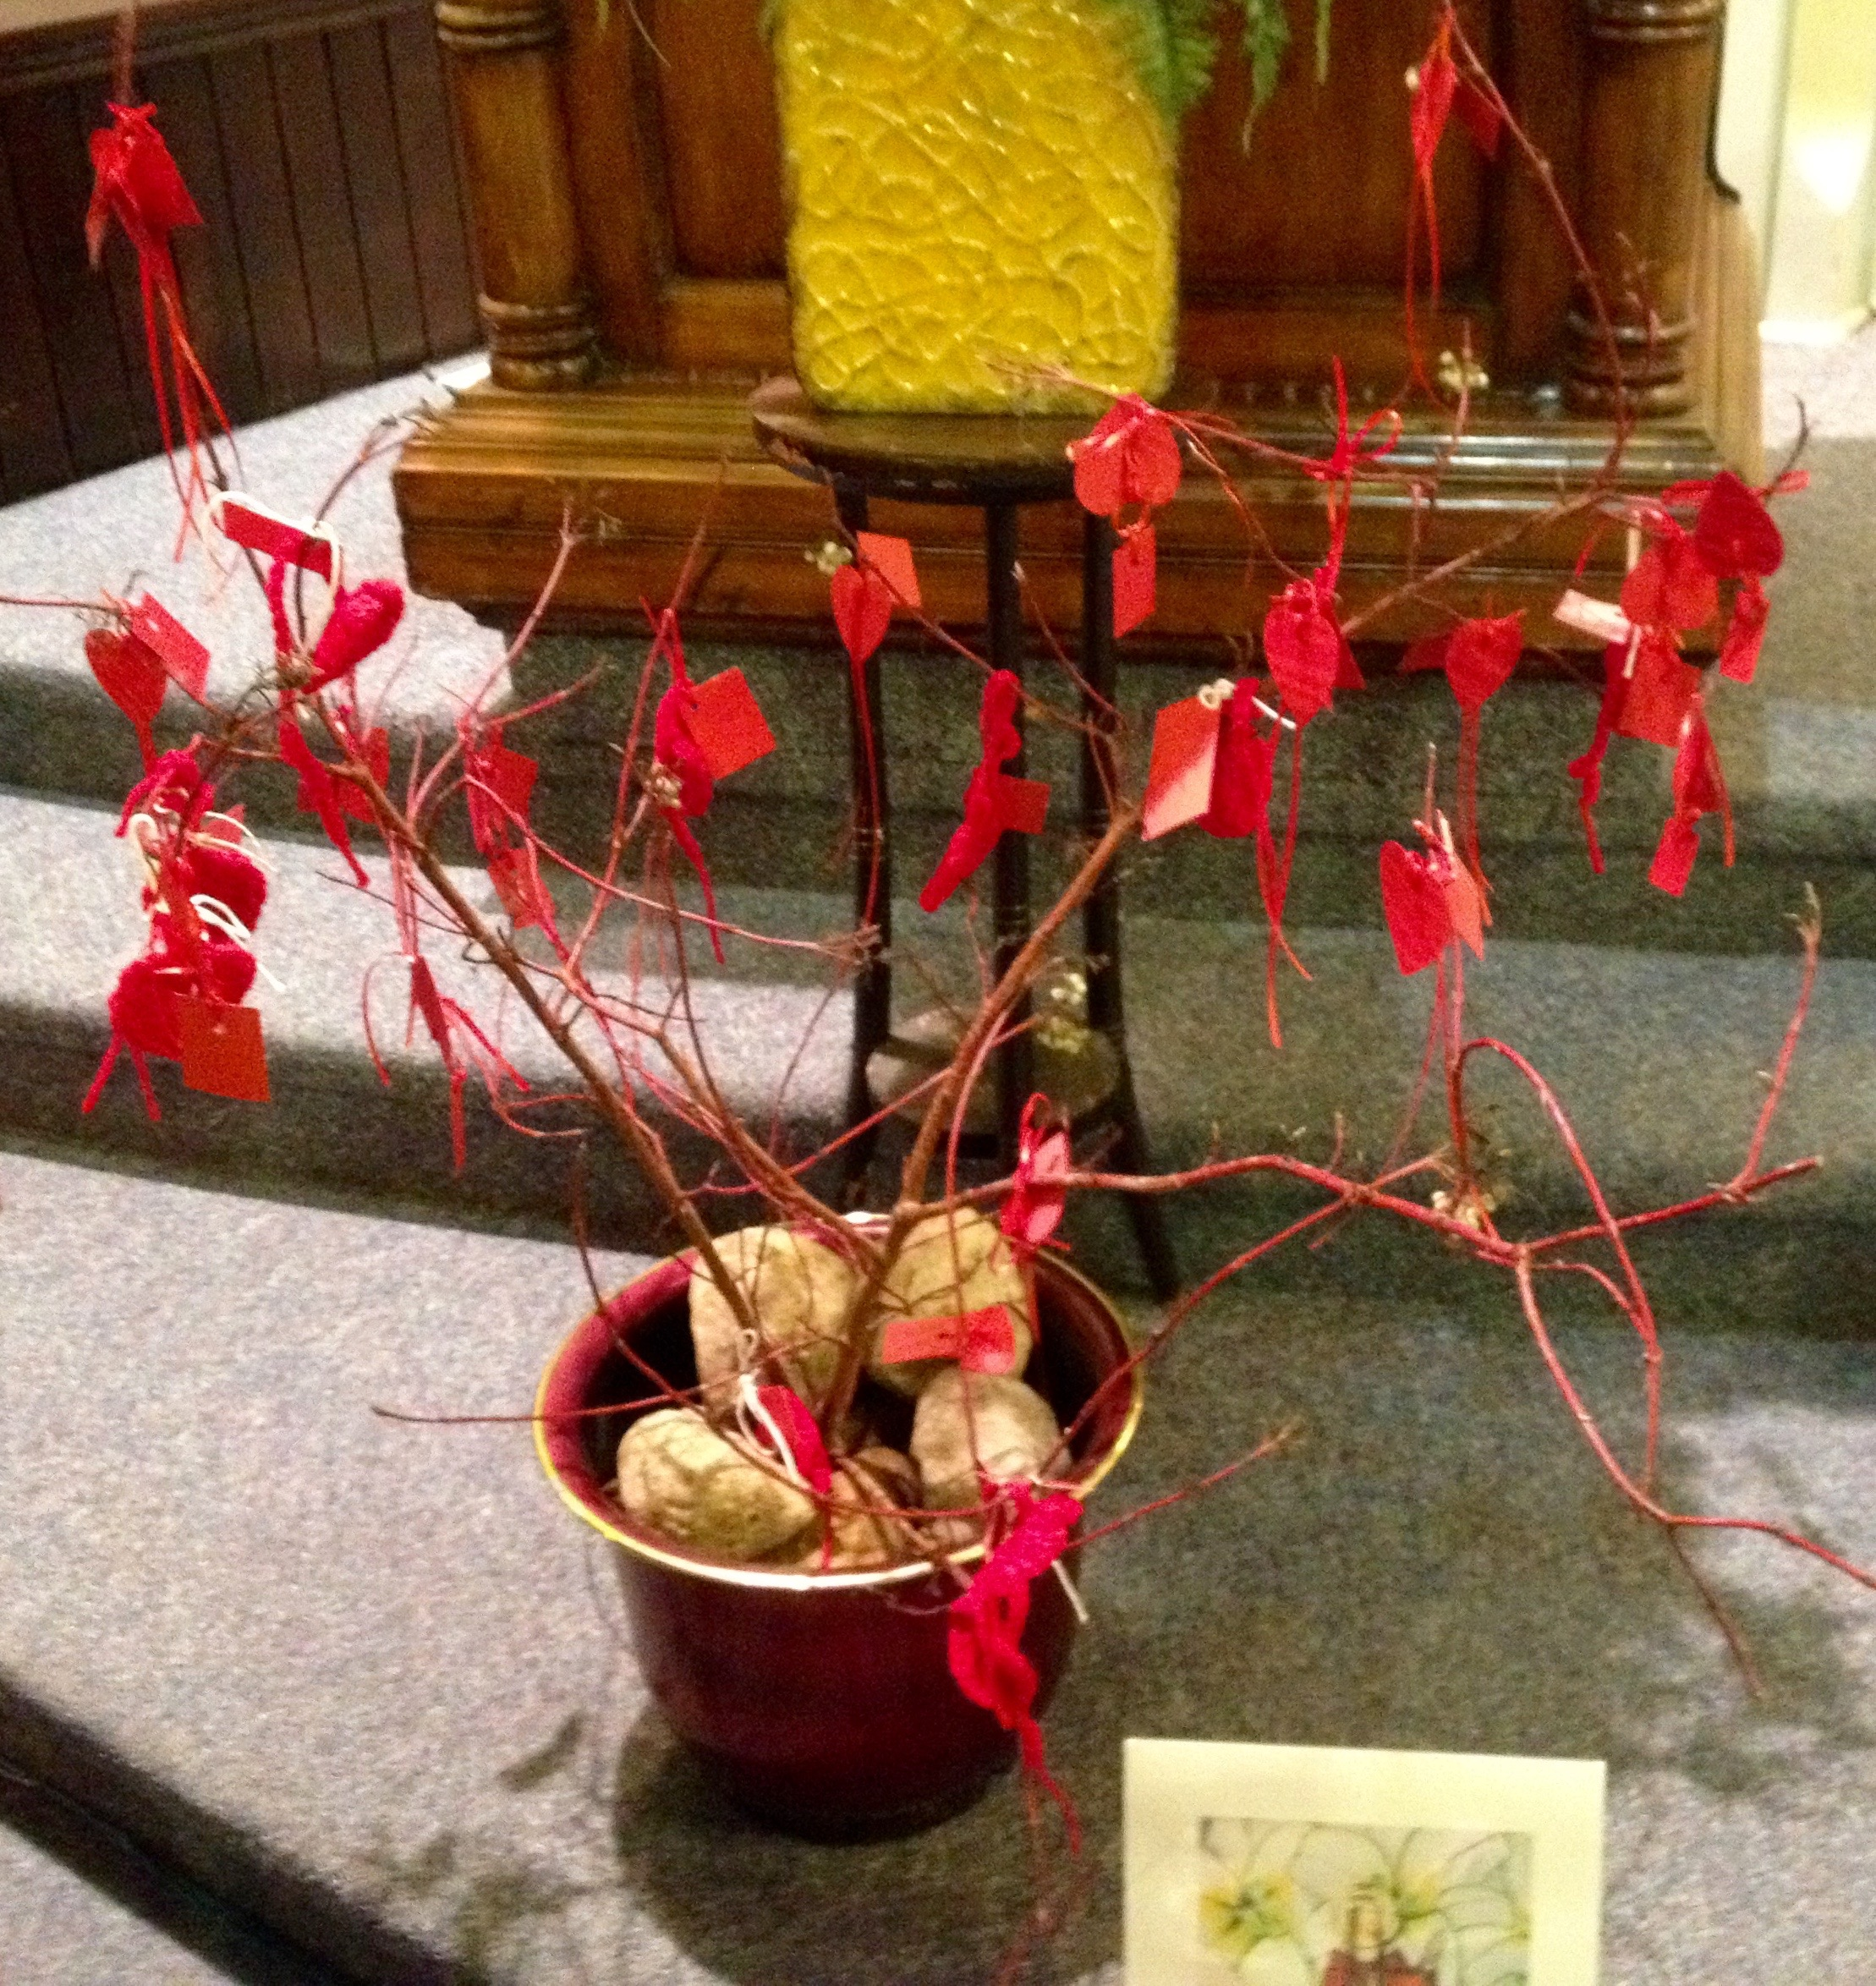
Members gathered for Mass and a Vigil before their October meeting. The Sisters in Spirit Vigil addition to the mass included a procession of candles and small red hearts with names of 30 murdered and missing Indigenous women and girls (MMIWG). Participants tied each red-ribboned heart to red dogwood branches and set the candles at the base of the ‘tree’, while each name was read aloud. A drawing of St. Kateri Tekakwitha was also on hand. The names of the Indigenous peoples of our Quinte area was shared; these included parts of the Iroquois Confederacy and the Algonkian/Ojibwa Nation.

We began with the prayer for MMIWG from the Native Women’s Association of Canada, followed by the hymn ‘They’ll Know We Are Christians’(by our love, by our love..). These particular lyrics were poignant:

We are one in the Spirit; we are one in the Lord, …
We will walk with each other; we will walk hand in hand, …
We will work with each other; we will work side by side, …
And we’ll guard each one’s dignity and save each one’s pride.

Participants received buttons with the Grandmother Moon logo and the Grandmother Moon prayer was recited at the end of the service. Indigenous women have a special connection to their grandmothers who passed on to the Spirit world. It is believed she teaches them about their sacred role as life-givers and the importance of being the heart of the family.

